

**Advanced Software Engineering**

Course # CSEE 5551 0001

Semester: Spring 2017

LAB Assignment # 4

Submission Date: 2/15/2017

Student Name: Satya Sai Deepthi Katta

Student ID: 16231371

**Instructor:** Dr. Yugyung Lee

**Email:** LeeYu@umkc.edu

**Department of Computer Science & Electrical Engineering**

**University of Missouri, Kansas City**

**Welcome to Lab Assignment #4 Wiki Page!**

Submission on 2/15/17

**Abstract:**

The main objective of this assignment is to provide an overview on creating an native android application using android studio. The application uses the help of "WORDS API" to find the meaning and parts of speech of the requested word.

**TASK: Create WireFrames for Android Application.**

**To present the rough view of the Android Application, Wireframes are created using online web service called creately.com.**

**Below provided are the screenshots for Wireframes of the My Dictionary Android Application.**

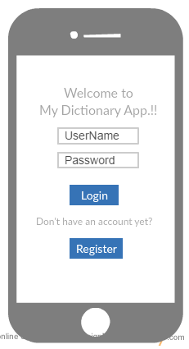

**Fig 1. Wireframe for Login Page of Android App.**

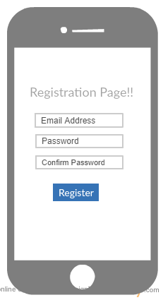

**Fig 2. Wireframe for Registration Page of Android App.**

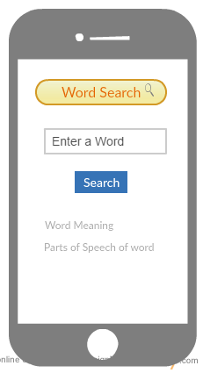

**Fig 3. Wireframe for Word Search Android App.**

**TASK 1: Create an Android App that uses any API of choice.**

An Android application is created using WORDS API, which displays the definition and parts of speech of the word entered. This is created in Android Studio and run on Android Emulator.

On launching the Application, the first screen is the login page

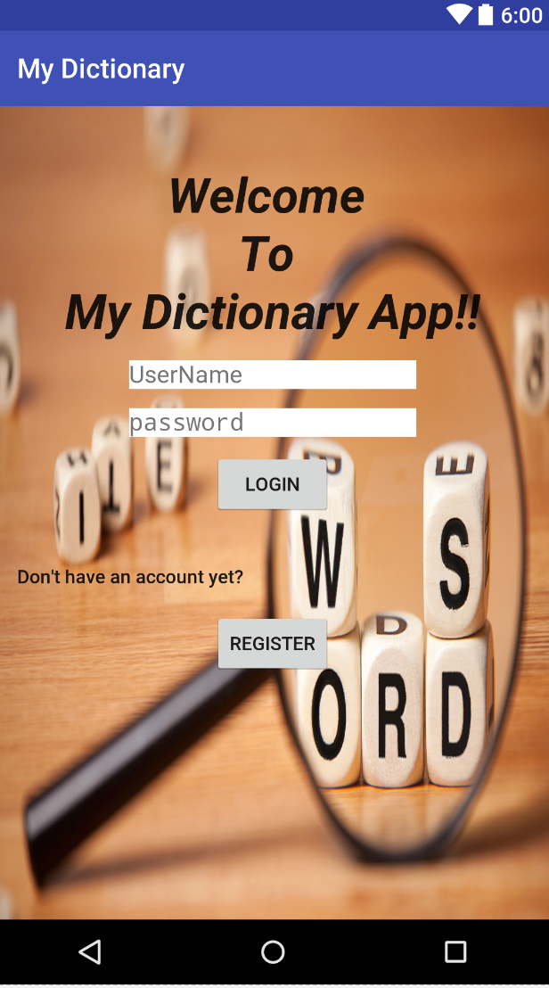

Fig 4. Login Page displayed after opening My Dictionary App.

Initially, any new user must register into the application by adding their email address and setting up a password.

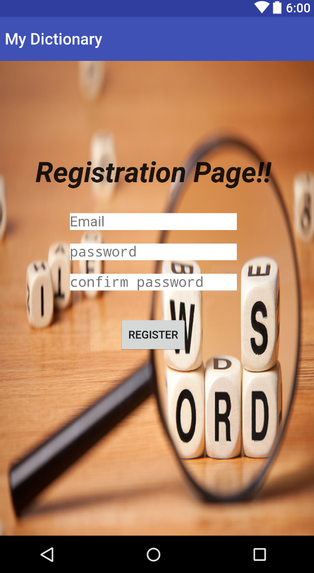

**Fig 5. Registration Page of My Dictionary Android App.**

Entering the correct credentials, login will move to home page, where they can give a word and find the meaning of the word and which part of speech word belongs to using "WORDS" API.

User can enter any word and click to proceed further.

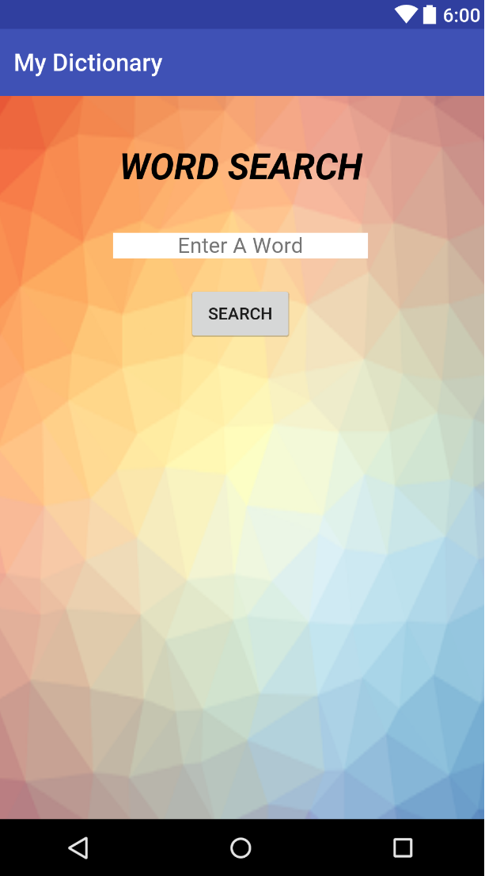

**Fig 6. Home Page for My Dictionary App.**

**TASK 2: Create 3 Pages for the App, namely Login, Registration and HomePage.**

The username and password are created for the admin account whose screenshot is given below. While registering, email should be in correct format. If not user is notified with a toast message. User is also notified if the given password and confirm password do not match each other

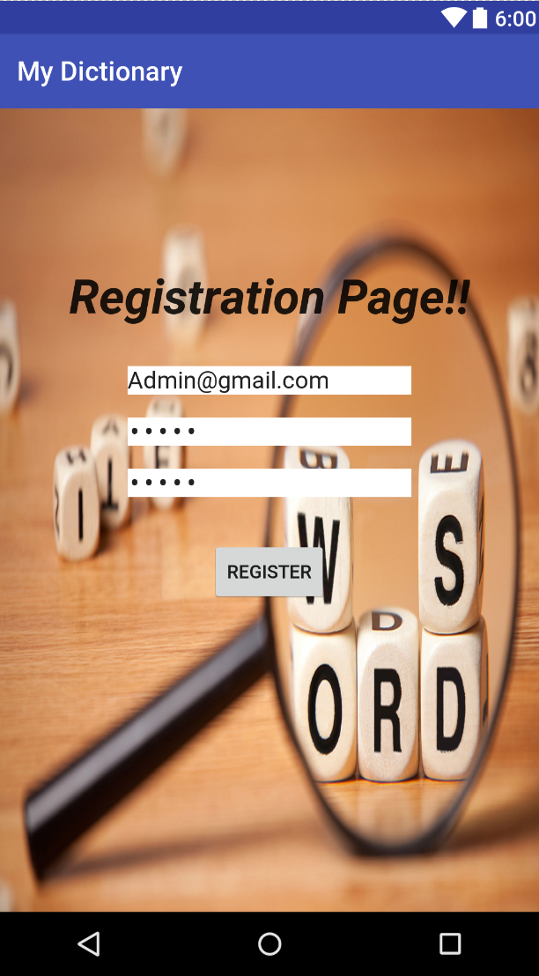

Fig 7. Admin Account created in Registration Page.

After successful registering into the application, user is redirected to login page to login into the app with the registered credentials.

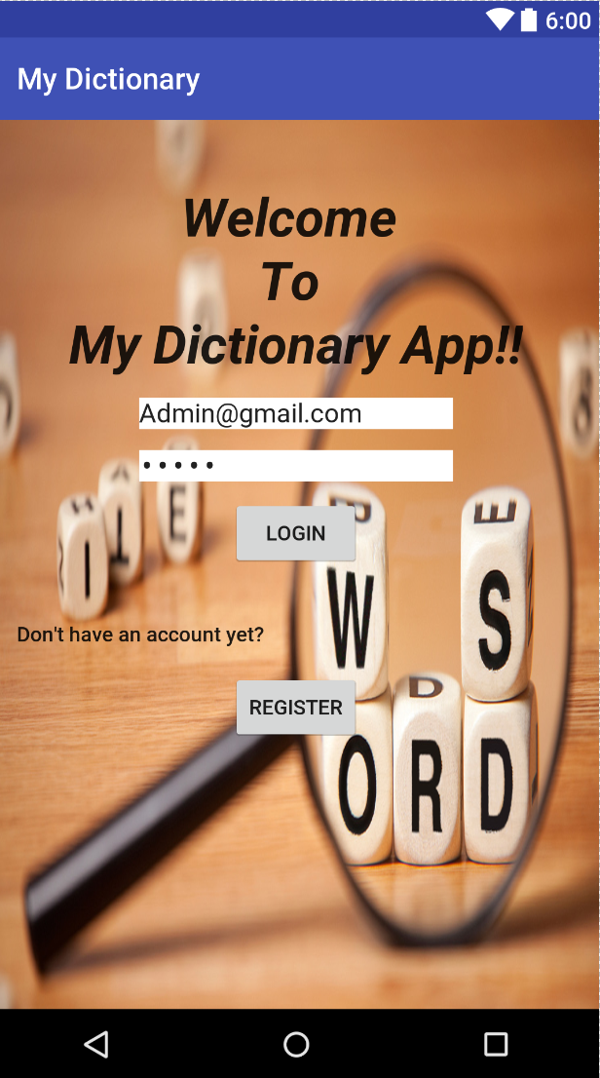

Fig 8. Using Admin account to login into the App.

Now the account is logged in with Admin credentials, the home page for My Dictionary Application is displayed.

A word search is performed and the results are displayed below.Definition and parts of the speech of the entered word are displayed with the help of Words API.

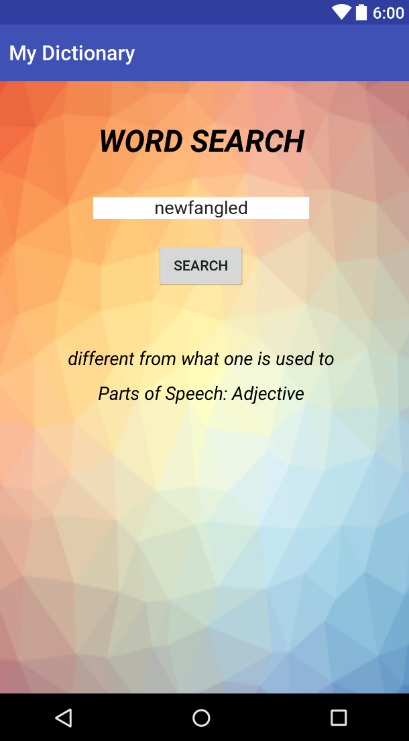

Fig 9. Word Search is performed in Home page of the Application.

**References:**

<https://market.mashape.com/wordsapi/wordsapi#definitions>